AD131 Control Software

LabVIEW 6i

Version A

(SP Document #1097332)
Spectral Products LLC

NOTICES

General:
This manual and the software it describes are provided free of charge as a service to the customer. The software is intended to be used as a tool for development and as an example of one possible method of code implementation.

Copyright:
SP maintains the copyright on this material, but grants the customer rights to use or modify the software described herein without obtaining SP’s permission and without the requirement to reference SP as the source of material.

Warranty:
This manual and the software described herein are provided “as is” with no warranty, expressed or implied.
While it is Spectral Products LLC’s intent to provide error-free useful development tools, no guarantee is made regarding the accuracy or ultimate usefulness of this material. SP reserves the right, without prior or further notice, to make changes to any of its products described or referred to herein to improve reliability, function, or design.

Liability:
SP accepts no liability for incidental or consequential damages arising from the use of this software.

Spectral Products LLC does not recommend the use of its components or software products in life support applications wherein a malfunction or failure of the product may directly threaten life or result in injury.

LabView® is a registered trademark of National Instruments.

TABLE of contents
1. Introduction 4
2. Installation 5
2.1. Checking System Requirement 5
2.1.1. Requirements for the Hardware 5
2.1.2. Requirements for the Software 5
2.2. Checking System Package Contents 5
2.3. Hooking up the AD131 5
2.4. Installing the Software 6
3. Getting Started 7
3.1. Using the Mouse and Drop-down Menu 7
3.1.1. The Mouse 7
3.1.2. The Drop-down Menu 7
3.2. Menus, Tool Bar, Controls and Indicators 7
3.2.1. Menus 7
3.2.1.1. File Menu 7
3.2.1.2. Operate Menu 8
3.2.1.3. Windows Menu 8
3.2.1.4. Help Menu 8
3.2.2. Toolbar 8
3.2.2.1. Description 8
3.2.2.2. Running VI 9
3.2.3. Controls and Indicators 10
3.2.3.1. Graph Control 11
3.2.3.2. Serial Port Setup and Cooler Control 12
3.2.3.3. Detector Setup 13
3.2.3.4. Thermo-Electric Cooler Status 14
3.2.3.5. Miscellaneous 14
4. Appendices 16
4.1. Appendix A – CM Novram Locations 16
4.2. Appendix B – DK Novram Locations 17
4.3. Appendix C - Wavelength Ranges 18
4.4 Appendix D - Serial Port & GPIB Error Codes 19

1. Introduction

The AD131 software provides a user-friendly, stand-alone interface to the AD131 Photodetector Module, which is designed to use with or without a thermo-electric cooled sensor.
The software is written in LabVIEW version 6.0 for Windows and runs on Window 2000. For fastest image display, the AD131 LabVIEW software should be run on a system with a video card and color monitor that can support 256-color graphics. In addition, the video driver, configured through Control Panel >> Display, must be set for at least 256 colors. Minimum requirements to view the file are 1024x768 pixel resolution and Microsoft Video for Windows driver. We strongly recommend 64MB of RAM and a Pentium processor for this version to run effectively.

2. Installation

Refer to the AD131 user manuals for proper power and communications, as well as any other pertinent installation information. The default setting for the AD131 communication port is COM2.

2.1. Checking System Requirement
Check to make sure that your computer meets the minimum requirements for the AD131 software.

2.1.1. Requirements for the Hardware
- 1 serial port.
- A mouse or any other pointing device.
- A VGA, SVGA display, or 1024x768.

2.1.2. Requirements for the Software
- Any IBM compatible machine with a Pentium processor
- A hard disk with at least 10MB free space, and 7MB is needed for installation.
- Microsoft Windows 95 or newer in standard or enhanced mode.
- Minimum of 64 MB of RAM recommended.

2.2. Checking System Package Contents
Check to make sure that your package contains all the following components. The AD131 system consists of:
- 1 AD131 photodetector module.
- 1 AD131 thermal electric (TE) cooler controller box (for units with TE cooling option).
- 1 power cable for units with TE cooling option, or a plug in power supply for a standard AD131.
- 1 Standard RS-232 cable (9 to 9 D sub) that is used to connect the computer serial port (default to COM2) to AD131 detector module.
- 1 Standard RS-232 cable (9 to 9 D sub) that is used to connect between AD131 head to TE controller box (for units with TE cooling option).
- 1 (5 to 5 DIN) cable that is used to connect between AD131 detector modules to TE controller box (for units with TE cooling option).
- 1 CD Software Installation disk
- 1 User Manual for the AD131.

2.3. Hooking up the AD131
Before making any connections from a computer port to AD131, the device should be off. For cable connections, refer to section 2.2 for cables.
- Connect the standard RS232 cable from a computer serial port to "9 pin" connector on the AD131 detector module.
- For units with TE cooling option, connect the TE cooler controller power cable to the power connector.
- For units without TE cooling option, connect the DIN connector from a plug in power supply to the AD131 module.

2.4. Installing the Software
Run the CD Software provided to install the AD131 software.
Note: If you do not have LabView installed on your system, you need to install the LabView RunTime engines also available on the CD Installation software.

3. Getting Started

Once the AD131 software has been installed, you are ready to get started.

3.1. Using the Mouse and Drop-down Menu

3.1.1. The Mouse
The mechanics of using a mouse with the AD131 software conforms to the Microsoft Windows standard. The following conventions are used in the manual when explaining manipulations with the mouse: “Clicking” the mouse on an object consists of moving the mouse cursor until it is pointing to the object and depressing the specified mouse button once or twice in quick succession. If you have reconfigured your mouse for other-handed use, switch the references (specified or assumed) to the right and left buttons.

3.1.2. The Drop-down Menu
Menu options are referenced as “to level menu”: “submenu option” like these following examples:
File
Open… is referenced as File:Open…

Help
Show Help is referenced as Help: Show Help

3.2. Menus, Tool Bar, Controls and Indicators
This section has detailed descriptions about the menus, tool bar, controls and indicators. For each menu, a brief description of each command is given. In addition, LabVIEW programs are called virtual instruments (VIs).

3.2.1. Menus

3.2.1.1. File Menu
- Open. Opens an existing VI. A status dialog is displayed while that VI is opening. This status dialog identifies the VIs that are currently being loaded and gives you an opportunity to cancel the load process.
- Close. Closes the active window and does not save any changes you have made.
- Page Setup. Allows you to customize the printer settings and modify how your VI's documentation is output, either to file or to a printer.
- Printer Setup… Sets configuration options for the printer. You can change the orientation of printout (landscape versus portrait). Printer Setup settings are saved with your VI.
- Print Window… Prints out the contents of the currently active window. Using this option, you can make a quick printout with the minimum number of prompts.
- Exit. Quits LabVIEW.

3.2.1.2. Operate Menu
- Print at Completion. Prints the contents of the front panel any time the VI completes execution.
- Log at Completion. Logs a time stamp and the data in all front panel controls of a VI to a separate datalog file.
- Data Logging. Displays data logging options. (Optional if you have LabVIEW software).
- Reinitialize All To Default. Sets all controls and indicators to their default values.

Windows Menu
- Show VI Info... Displays the VI file path, revision number, and memory usage.
- Full Size. Uses the entire screen to display the active window.

3.2.1.4. Help Menu
- Show Help. Is a Context-sensitive Help window that displays a function’s or VI’s parameters, parameter type definitions, and the description for the object.
- About. Information on LabVIEW software version number and serial number.

3.2.2. Toolbar

3.2.2.1. Description
The LabVIEW toolbar contains four command buttons as in figure 1.

Fig. 1. LabVIEW Toolbar
Run button. Runs the VI.


Continuous run button. Runs the VI over and over.

Stop button. Aborts VI execution.

Pause/Continue button. Pauses VI execution/Continue VI execution.

3.2.2.2. Running VI
You can run a VI by selecting Operate:Run or clicking on the run button.


While the VI is executing, the run button changes appearance. If the VI is running at its top level, the run button looks like the illustration shown to the left.

If the VI is executing as a sub VI, the run button changes to look like the illustration shown to the left.


The Return to Caller button appear when a suspended sub VI is not executing. Click it to return to the caller VI. Notice you can return to a caller without executing the current VI. If you want to execute it, be sure to press the Run button before returning to the caller.


The Skip to Beginning button will make the VI go back to the beginning

3.2.3. Controls and Indicators
After the AD131 software is launched, the main window appears on the computer screen as shown in figure 1. Then, several seconds later, the ‘Serial port setup.vi’ window also appears on the screen as shown in figure 2. The second window will allow you to select a serial port that connected to AD131 module, and also allow you control the Themo-Electric (TE) cooled device (for units with TE cooling option). In the ‘Cooler Control’ box, you can turn on/off the power and the cooling of the TE cooler by clicking on the dialog checkboxes. In order to set the parameters on the ‘Serial port setup.vi’, the ‘SET’ button must be clicked. To start collection data, click on ‘EXIT’ button to close the setup window, and the figure 1 is the main window of the software.

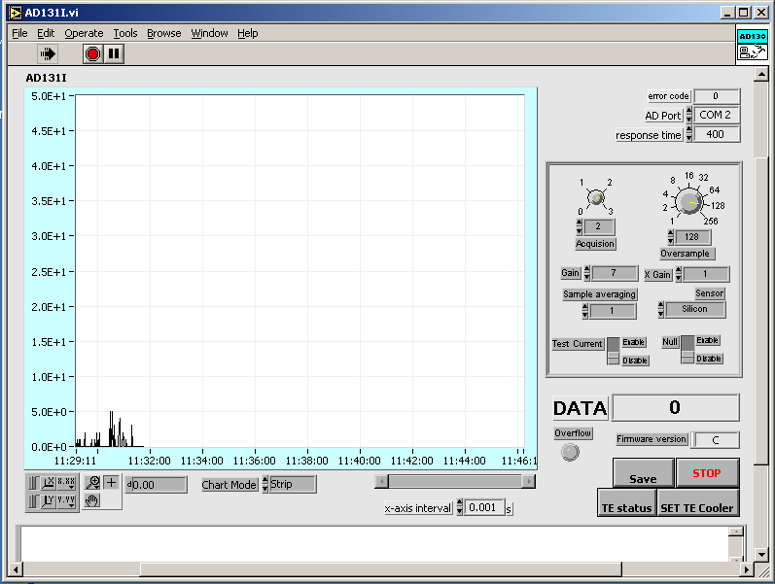
Fig. 1. Main screen
In the main screen, there are Graph, Graph control, Chart Mode, TE status, SET TE Cooler, Save, STOP, DATA, AD131 control, AD Port, response time, and error code.

3.2.3.1. Graph Control

AutoScale (X or Y) - Turns autoscaling on or off. If pressing the X AutoScale button, shown at the left, the graph AutoScale the x-axis. If pressing the y AutoScale button, the graph AutoScale the y-axis.
Lock Scale - Clicking the lock switch, the graph will continuously autoscale.

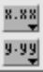
Scale Format - Maintains run-time control of the format of the x and y scale markers respectively.


In standard operate mode, the plus or crosshatch is indicated. In operate mode, you can click in the graph to move cursors around.


Panning Tool - Switches to a mode in which you can scroll the visible data by clicking and dragging the plot area of the graph.

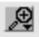
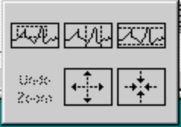
Zoom Tool - Zooms in or out on the graph. Clicking the zoom tool, you see a pop-up menu to choose methods of zooming. This menu is shown in the following illustration.

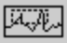
Zoom by rectangle.

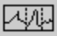
Zoom by rectangle, with zooming restricted to x data (the y scale remains unchanged)

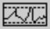
Zoom by rectangle, with zooming restricted to y data (the x scale remains unchanged)

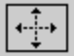
Zoom in about a point. If you hold down the mouse on a specific point, the graph continuously zooms in until you release the mouse button.

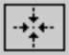
Zoom out about a point. If you hold down the mouse on a specific point, the graph continuously zooms out until you release the mouse button.

3.2.3.2. Serial Port Setup and Cooler Control
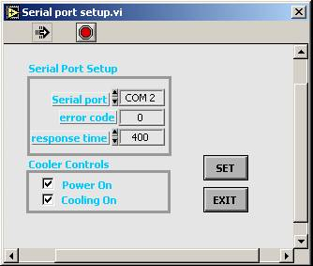

There are two ways to get the Serial Port Setup.vi to display on screen: the first time to start the file, or by clicking on SET TE Cooler button.
Serial port – Is the serial port that connected to the AD131.
error code – Is –1 if baud rate, data bits, parity, or port number are out range, or if the serial port could not be initialized.
response time – Is the waiting time to set for returned data from AD131.

Fig. 2. Serial Port Setup and Cooler Controls
Power on – Turns on/off the TE cooler power supply. The power LED indicator turns red if the power is on.
Cooling On – Controls the TE cooler temperature. The cooling LED indicator turns green when the sensor reaches a preset temperature. Otherwise, the LED is red when the cooling is on.
SET – Activates the parameters in the Serial Port Setup and Cooler Controls.
EXIT – Closes the Serial port setup.vi

3.2.3.3. Detector Setup
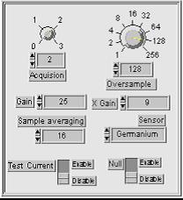
Acquisition – Sets the K(2bits) number of the acquisition period before the measurement begins. K has the following meanings:
0: 1 Reset clock period (RCP), 0 clock period Acquisition Time (AT), CDS disabled, no initial data point.
1: 1 RCP, 0 clock period AT, CDS enabled.
2: 1 RCP, 15 clock period AT, CDS enabled. (recommended)
3: 1 RCP, 31 clock period AT, CDS enabled.

CDS = Correlated Double Sampling

Fig. 3. Detector Setup
Oversample - Is the number of oversamples/integration used at the beginning and end of each integration cycle by the Correlated Double Sampling function. The final value is subtracted from the initial value; eliminating several noise sources.
Gain - Selects a new Gain value between 1 and 255. The integration period is indirectly a function of Gain. The integration period of Gain is multiplied by the X Gain factor. The signal is amplified by gathering charge for a longer duration for higher gain settings.
XGain - Is a coarse gain between 1 and 255. Integration period of GAIN is multiplied by coarse gain factor.

Sample averaging - Selects the number of measurements to be averaged before a final value is returned from the AD131: 1, 2, 4, 8, 16, 32, 64, or 128.
Sensor – Selects sensor type, which is Silicon, Germanium/InGaAs, or PbS/PbSe.
Test Current - Enables the internal test current, or disables it. The internal test current is approximately 200 nA, and is added to the value of any other input current.

Null – Enables the null function and refreshes its value, or disables the offset null. Null should not be enabled until all other desired setup parameters are set. The null function takes a series of measurements with the set parameters, storing the lowest of these readings for subtraction from all subsequent measurements.

Firmware version – Is an ascii value of the installed AD131 firmware version.
Serial port - Is serial COM port that connected to the AD131 Serial port.
error code - Is the error code in communications with AD131.
Time delay – Is the waiting time to set for returned data from detector.
Power on/off – Turns on/off the temperature controller power.
Cooling on/off – Turns on/off the thermo-electric cooled sensor.
SET - Sets all parameters in the setup.vi.
EXIT – Exits the setup.vi

3.2.3.4. Thermo-Electric Cooler Status
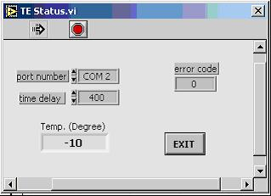
Serial port – Is the serial port that connected to the AD131.
time delay – Is the waiting time for the returned data from AD131.
error code – Is 0 if no error has occurred.
Temp. (Degree) – Is the current sensor temperature.
EXIT – Closes the TE Status.vi

Fig. 4. Themo-Electric Cooler Status

3.2.3.5. Miscellaneous
Chart Mode - Is the chart update mode, which has three items: strip chart, scope chart, and sweep chart.
The strip chart mode has a scrolling display similar to a paper tape strip chart recorder. As each new value is received, it is plotted at the right margin, and old values shift to the left.
The scope chart mode has a retracting display similar to an oscilloscope. As each new value is received, it is plotted to the right of the last value. When the plot reaches the right border of the plotting area, the plot is erased and plotting begins again from the left border. The scope chart is faster than the strip chart because it is free of the processing overhead involved in scrolling.
The sweep chart mode acts much like the scope chart, but it does not blank when the data hits the right border. Instead, a moving vertical line marks the beginning of new data and moves across the display as new data is added.
error code – Is –1 if baud rate, data bits, parity, or port number are out range, or if the serial port could not be initialized.
AD Port – Is the serial port that connected to the AD131. This port is the copy from the serial port in Serial Port Setup.vi
DATA – Is three bytes, which returned from AD131.
Firmware version – is an ASCII value of the installed AD131 firmware version.
Overflow – Is a round indicator. It turns red if overflow or underflow has occurred in DATA.
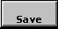
- Saves the current x, y data on the screen to ‘x tab y’ format file.
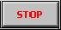
- Stops running the vi.
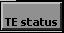
- Activates the TE status.vi as shown in figure 4.
- Activates the Serial Port Setup.vi as shown in figure 2.

4. Appendices

4.1. Appendix A – CM Novram Locations

Address | QUERY | STATUS MESSAGE
0 | Position | Current wavelength in current units.
1 | Type | 0: Single, 1: Additive, 254: Subtractive.
2 | Groove/mm | Current grating ruling (g/mm).
3 | Blaze (nm) | Current grating blaze wavelength (nm).
4 | Current grating | Number of grating currently being used (1-2).
5 | Scan speed | current scan speed in Å/sec.
6 | Step size | current size in current units.
7 | Zero Off.m1g1 | zero offset of machine 1, grating 1.
8 | Zero Off.m1g2 | zero offset of machine 1, grating 2.
9 | Zero Off.m2g1 | zero offset of machine 2, grating 1.
10 | Zero Off.m2g2 | zero offset of machine 2, grating 2.
11 | Cal. m1g1 | Calibration number of machine 1, grating 1.
12 | Cal. m1g2 | Calibration number of machine1, grating 2.
13 | # of grating | number of gratings installed in machine 1.
14 | Current units | 0: centi-Microns, 1: Nanometers, 2: Angstroms.
15 | Gr/mm m1g1 | grating ruling of machine 1, grating 1.
16 | Blaze m1g1 | grating blaze of machine 1, grating 1.
17 | Gr/mm m1g2 | grating ruling of machine 1, grating 2.
18 | Blaze m1g2 | grating blaze of machine 1, grating 2.
19 | Serial number | Monochromator’s serial number.
20 | Novram #14 | Not used.

4.2. Appendix B – DK Novram Locations
Address | The meaning of the content
1 | AAAAH if programmed, else random
2 | Serial Number
3 | Source 1 (not used)
4 | Source 2 (not used)
5 | Source 3 (not used)
6 | Source 4 (not used)
7 | High byte: Current source (not used) Low byte: IEEE address
8 | Number of motor steps of Slot 1
9 | Number of motor steps of Slot 2
10 | Number of motor steps of Slot 3
11 | Grating 1 Blaze
12 | Grating 2 Blaze
13 | Grating 3 Blaze
14 | Zero Offset of Machine 1, Grating 1
15 | Zero Offset of Machine 1, Grating 2
16 | Zero Offset of Machine 1, Grating 3
17 | Zero Offset of Machine 2, Grating 1
18 | Zero Offset of Machine 2, Grating 2
19 | Zero Offset of Machine 2, Grating 3
20 | Grating 1 Calibration, High byte
21 | Grating 1 Calibration, Low byte
22 | Grating 2 Calibration, High byte
23 | Grating 2 Calibration, Low byte
24 | Grating 3 Calibration, High byte
25 | Grating 3 Calibration, Low byte
26 | Entrance Slit Offset
27 | Exit Slit Offset
28 | Middle Slit Offset, for DK242 only
29 | High byte: # of gratings  Low byte: Bit 0 – 0 = Full step, 1 = Micro step (1)  Bit 1 – 0 = 1 machine, 1 = 2 machine (2)  Bit 2 – 0 = no OMA, 1 = OMA (4)  Bit 3 – 0 = no CSR, 1 = CSR (8)  Bit 4 – 0 = no GPIB, 1 = BPIB (16)  Bit 5 – 0 = Unilateral, 1 = Bilateral (32)
30 | Model Number
31 | Grating 1 groove/mm
32 | Grating 2 groove/mm
33 | Grating 3 groove/mm
34 | Machine 2 Slot 1
35 | Machine 2 Slot 2
36 | Machine 2 Slot 3
37 | Hi byte not used Low byte subtractive
38 | Reserved
39 | Reserved
40 | Reserved
41 | Reserved

4.3. Appendix C - Wavelength Ranges
The CM/DK is restricted to angles between 0 and 70 degrees. The upper restriction is imposed because the grating is almost edge-on to the incident beam beyond this angle.
From these restrictions, one may use the grating equations to calculate the valid ranges and step sizes for any particular grating. The table below lists the maximum wavelength for each grating set in the CM/DK software.

Upper wavelength scan limit AND MAXIMUM WAVELENGTH
INCREMENTS PER ANGULAR STEP FOR DIFFERENT GRATINGS
(Lower wavelength scan limit is zero)

Grating Upper limit
Grv/mm | nm
3600 | 500
2400 | 750
1800 | 1000
1200 | 1500
600 | 3000
300 | 6000
150 | 12000
75 | 24000

4.4 Appendix D - Serial Port & GPIB Error Codes

Serial port error contains the most recent error code reported by any of the serial port VIs. The following table shows the possible values for Serial Port error

Serial &GPIB  error | Symbolic  Status | Description
0 | EDVR | Error Connecting to Driver
1 | ECIC | Command Requires GPIB Controller to be CIC
2 | ENOL | Write Detected No Listeners
3 | EADR | GPIB Controller Not Addressed Correctly
4 | EARG | Invalid Argument or Arguments
5 | ESAC | Command Requires GPIB to be System Controller
6 | EABO | I/O Operation Aborted
7 | ENEB | Non-existent Board
8 | EDMA | DMA Hardware Not Detected
9 | EBTO | DMA Hardware uP Bus Timeout
11 | ECAP | No Capability
12 | EFSO | File System Operation Error
13 | EOWN | Shareable Board Exclusively Owned
14 | EBUS | GPIB Bus Error
15 | ESTB | Serial Poll Byte Queue Overflow
16 | ESRQ | SRQ Stuck On
17 | ECMD | Unrecognized Command
19 | EBNP | Board Not Present
20 | ETAB | Table Error
30 | NADDR | No GPIB Address Input
31 | NSTRG | No String Input (Read)
61 | EPAR | Serial Port Parity Error
62 | EORN | Serial Port Overrun
63 | EOFL | Port Receive Buffer Overflow
64 | EFRM | Serial Port Framing Error
65 | SPTMO | Serial Port Timeout, Bytes Not Received at Serial Port

